Thursday 19 September

* **GITHUB:** [**https://github.com/qwan3201/Infosys320G2**](https://github.com/qwan3201/Infosys320G2)

## **Problem Definition**

* + *What is the problem?*
    - Language Students only have each other to converse with, their language vocab are on the same level which means they would be learning the same things
    - Learning a language often works best if you consistently engage in conversation with native speakers. Physical limitations makes this difficult.
    - Students learn a small set of vocab, while interacting with peers, it is difficult to prolong the conversation
  + *Who does the problem affect?*
    - School students studying a second language
  + *What is the impact of the problem?*
    - Students do not increase their level of knowledge of the language except in class
    - Most students do not continue engaging in the language after finishing school
  + *What would a good solution look like?*
    - An ideal solution is to have an interactive space between two students who are learning each others’ first language
    - The students will run through scenes of activities to do together, which are simple enough to converse in a language together
    - Consistent language exposure in a social space is the optimal environment for successful language learning.
    - A lobby will be used for students to find another person to interact with, they have the potential to create lifelong friendships which helps students continue their language learning after finishing school

1. Would be fantastic to utilise photon in a classroom setting. This would be useful in the circumstance where you have two schools both of which have a curriculum that involves learning a language. The idea is that you have 2 schools in different locations learning a language e.g. one learning French (English speaking), the other learning English (French speaking). These 2 classes can have a shared space in virtual reality where they can more or less help each other out in learning each others languages. This could include objects in scene i.e. an apple and have an individual grab it where then the other student will have to say what that object is in the corresponding language they are learning. Would be useful to have voice to text/subtitles to enhance the learning. In conjunction to this you could have scenes where the student has to interact in a real life setting. e.g. a French waitress asks what they would like to order, the person should reply in the correct phrase, which would then trigger the next scene/task.

## **Agile Methodology**

* + Iterative and incremental development
  + Foster an open communication style
  + Continuous learning from experiments
  + SCRUM meetings
  + We need to embrace a changing environment
  + As a group, we need to create and prioritize a product backlog (work to be done)
  + As individuals, we need to select items from the backlog and determine how to complete the work
  + Work must be completed within a sprint (usually two to four weeks)
  + Need to update our Trello board each day/couple of days to get progress updates
  + Team members should be encouraged to conduct peer reviews at the end of each sprint.
  + The process then starts back up again until all work or backlog is complete.

## **User Stories**

1. As a French language learning student, I want to be able to have a conversation with an individual in French so that I can improve my French comprehension.
2. As a French language learning student I want to be able to have a conversation with an individual in French so that I can improve my verbal French skills.
3. As an English language learning student, I want to be able to have a conversation with an individual in English so that I can improve my English comprehension.
4. As an English language learning student I want to be able to have a conversation with an individual in English so that I can improve my verbal English skills.
5. As a language learning student, I want to find others I can converse with so I can continue learning my new language after finishing school.

## **Working Prototype - Project needs to be in Github**

## **Interaction in prototype**

## **Make a summary in PowerPoint of all screenshots with titles that you would use in a quick presentation of your prototype and beyond (bullet points) (hand drawn too)**

## **Plan for the future/ backlog/ToDo**

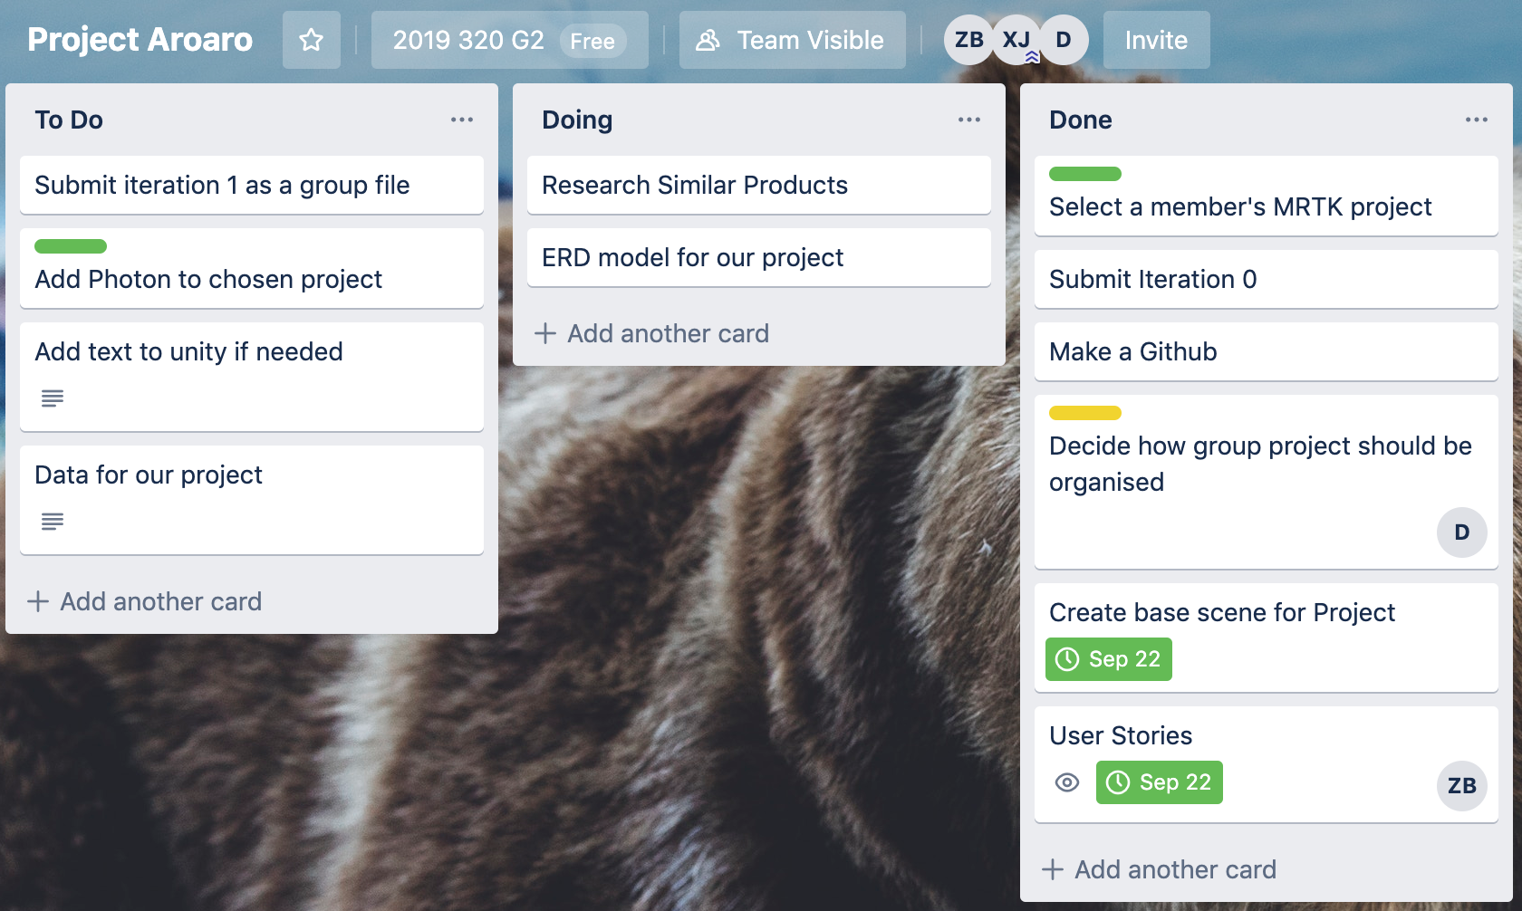

## 

## 

## 

## 

## 

## 

## 

## 

## 

## 

## **MRTK setup**

- Build Complete

-

## **Working Photon**

## **Information Model - ERD**

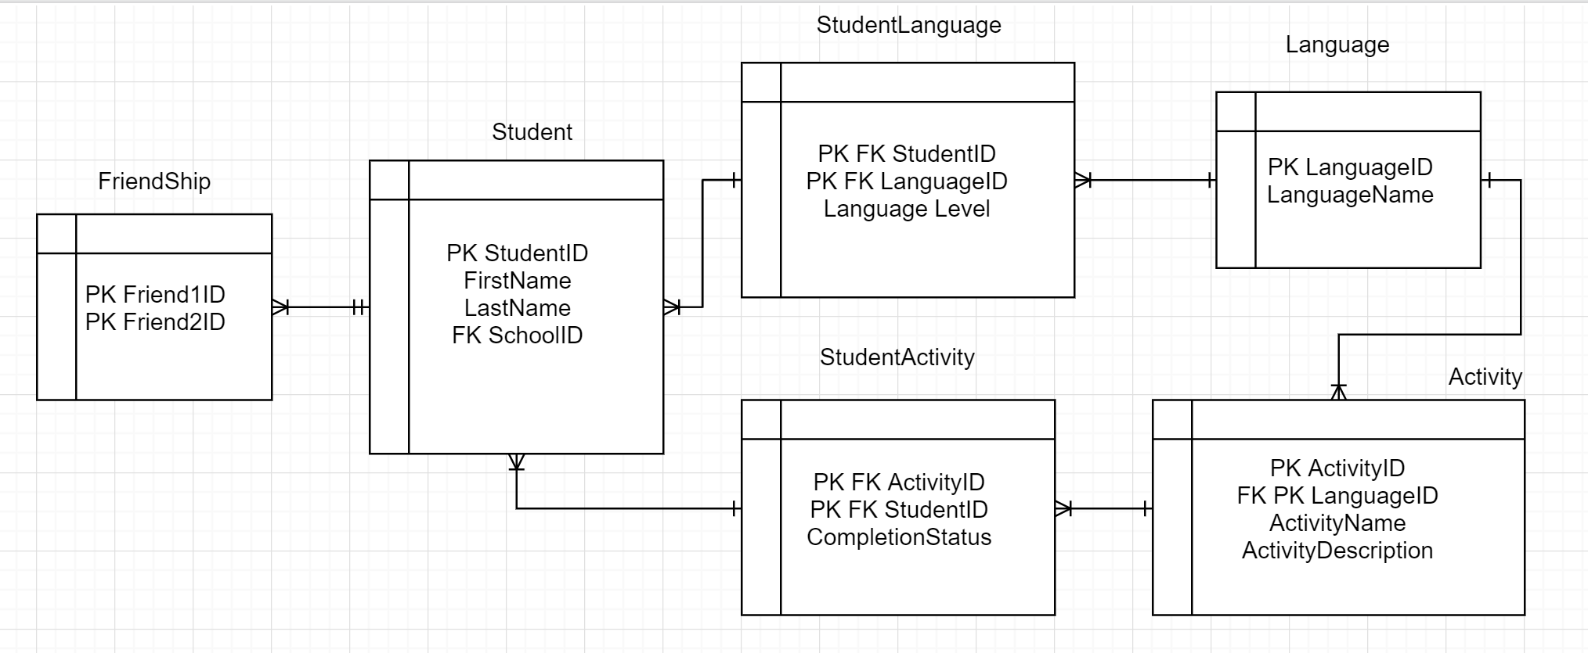  
<https://drive.google.com/drive/u/3/folders/1U9GvKaaVwGBKoZk1IhdmhN7iX35zDquq>

## **Assets which will/may be used**

## **Research of similar work**

|  |  |  |
| --- | --- | --- |
| Mondly | ImmerseMe | Fluentu |
|  |  |  |
| Mondly is a language learning tool that combines speech recognition and AR to make language learning more intuitive. | ImmerseMe is a language learning tool that uses VR to bring the world to its users so that when you travel to these places, “you’ll be prepared” | Offered for both desktop and mobile, Fluentu uses authentic video content (video trailers, news, inspiring talks, etc) to help users engage and learn Chinese. |

## 